Answer the following questions:

* 1. Are DHCP messages sent over UDP or TCP?

UDP

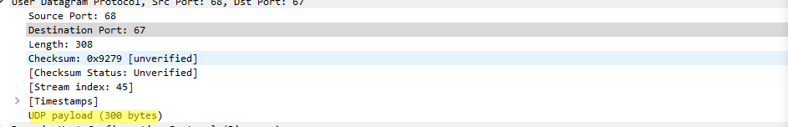

* 1. Draw a timing datagram illustrating the sequence of the first four-packet Discover/Offer/Request/ACK DHCP exchange between the client and server. For each packet, indicated the source and destination port numbers. (choose Flow Graph from statistics-tick on limit to display filter).

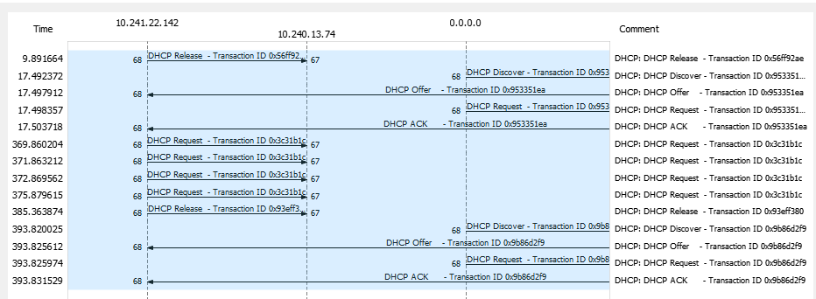

* 1. What is the link-layer (e.g., Ethernet) address of your host?

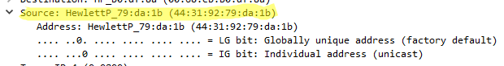

* 1. What values in the DHCP discover message differentiate this message from the DHCP request message?

DHCP Message Type

Request includes a server identifier field

* 1. What is the value of the Transaction-ID in each of the first four (Discover/Offer/Request/ACK) DHCP messages? What are the values of the Transaction-ID in the second set (Request/ACK) set of DHCP messages? What is the purpose of the Transaction-ID field?

**First set**

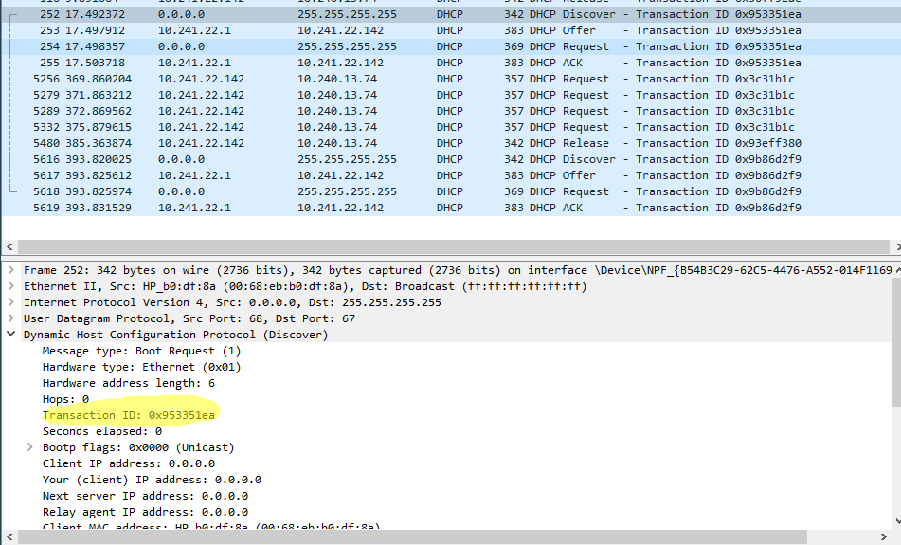

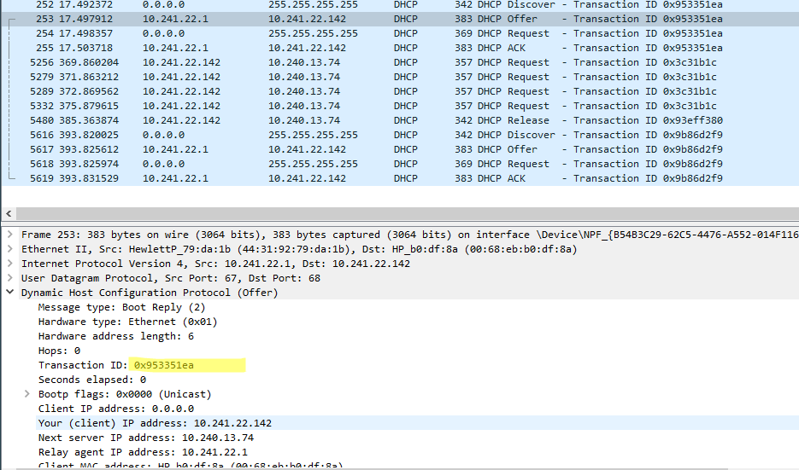

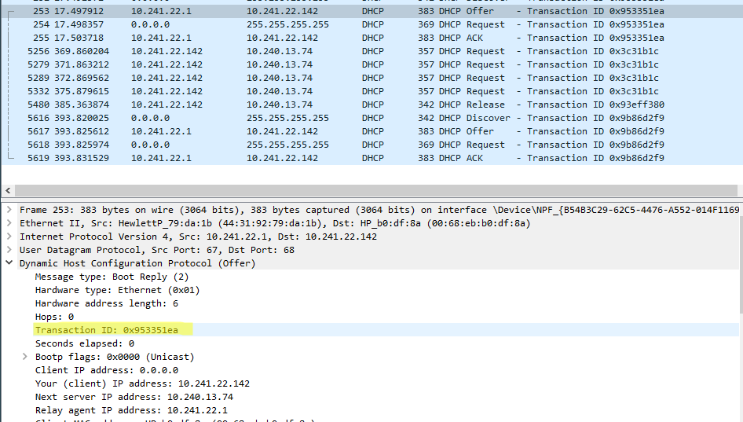

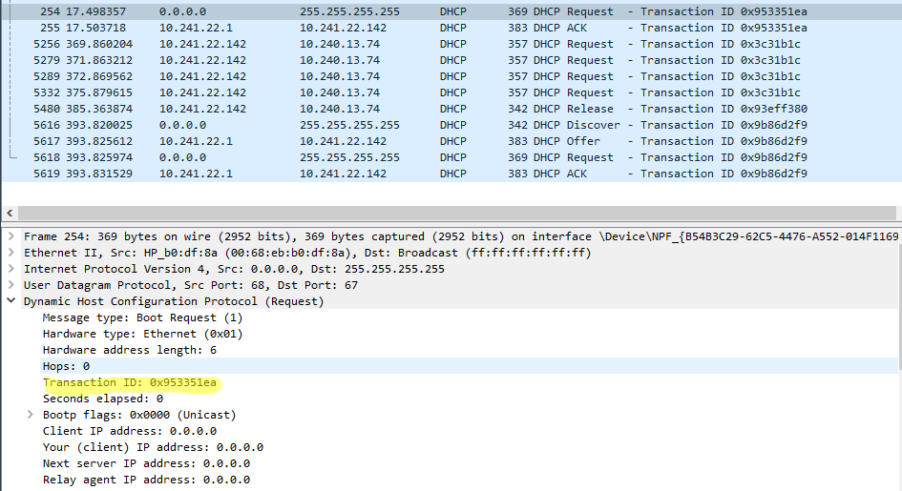

**Second Set**

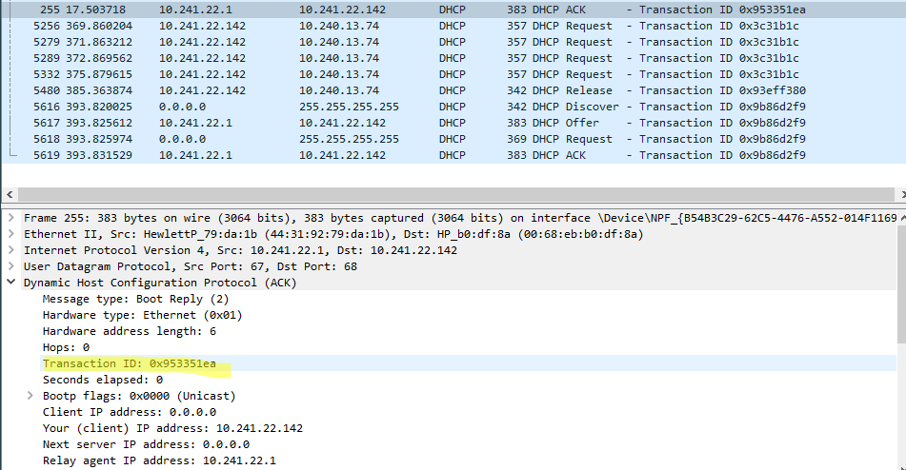

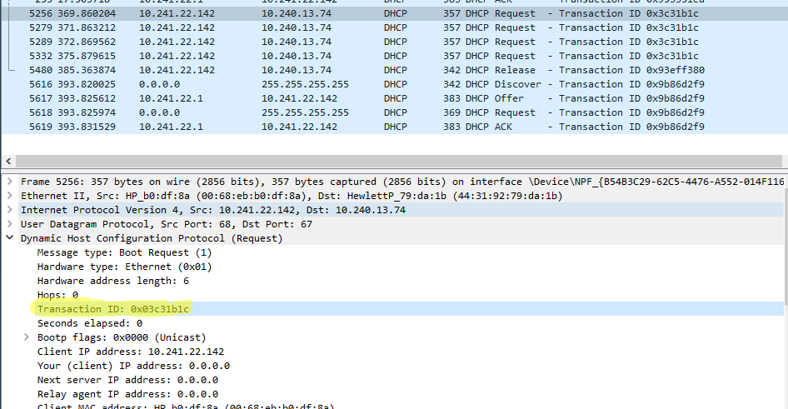

**Purpose is that the transaction ID is different so that the host can differentiate between different requests made by the user.**

* 1. What is the IP address of your DHCP server?



* 1. What IP address is the DHCP server offering to your host in the DHCP Offer message?

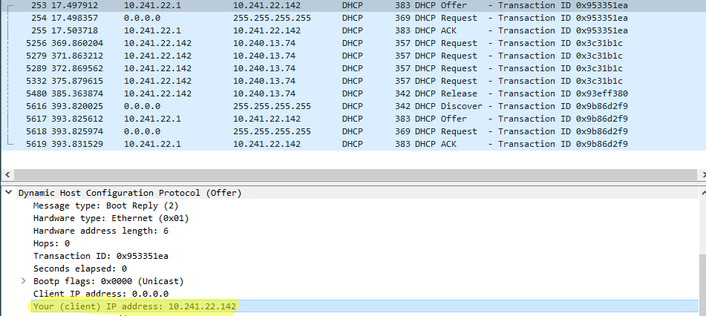

* 1. Is there a relay agent in your experiment? If so, what is the IP address of the agent?

**Yes, there is.**

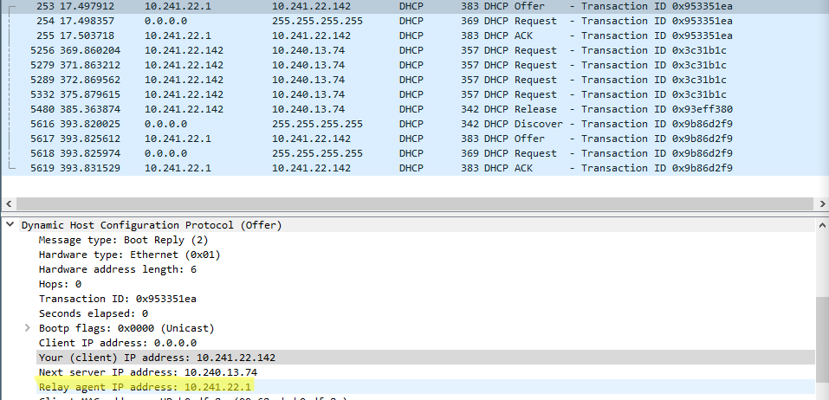

* 1. Explain the purpose of the lease time. How long is the lease time in your experiment?

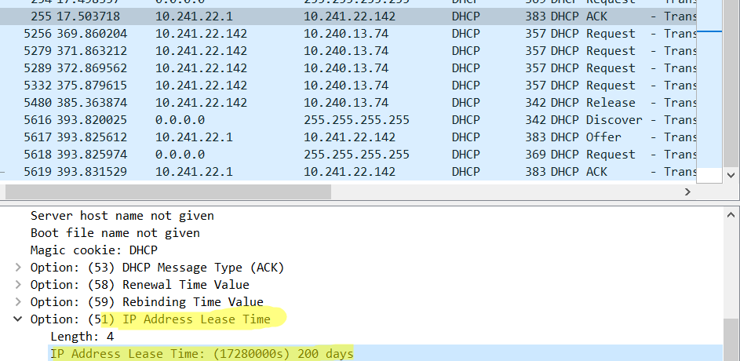

**The purpose of lease time is to tell the client how long they can use the specific IP address assigned by the server before they will have to be assigned a new one.**

**#Part1 DNS**

* 1. Locate the DNS query and response messages. Are then sent over UDP or TCP?

By using the UDP

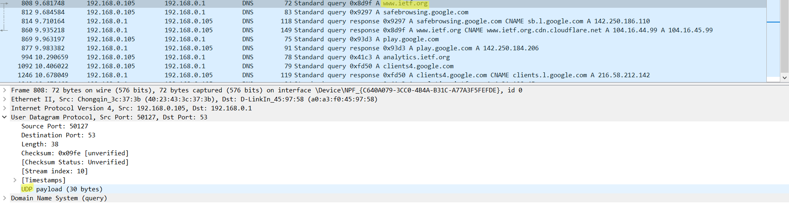

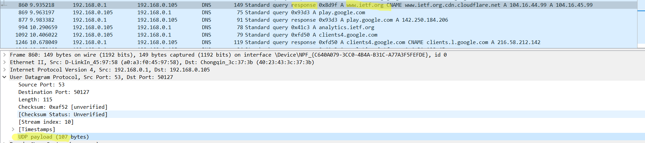

* 1. What is the destination port for the DNS query message? What is the source port of DNS response message?



* 1. To what IP address is the DNS query message sent? Use ipconfig to determine the IP address of your local DNS server. Are these two IP addresses the same?

Yes, the IP address of my local DNS server is the same as, the destination.

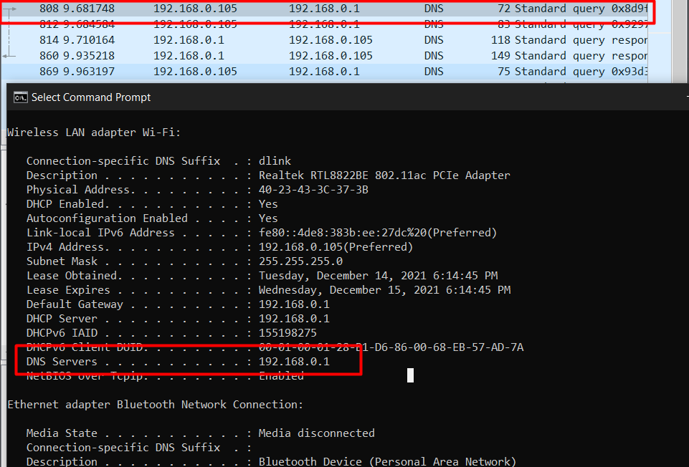

* 1. Examine the DNS response message. How many “answers” are provided? What does each of these

answers contain?

The response message contained answers to the query which was the sites address

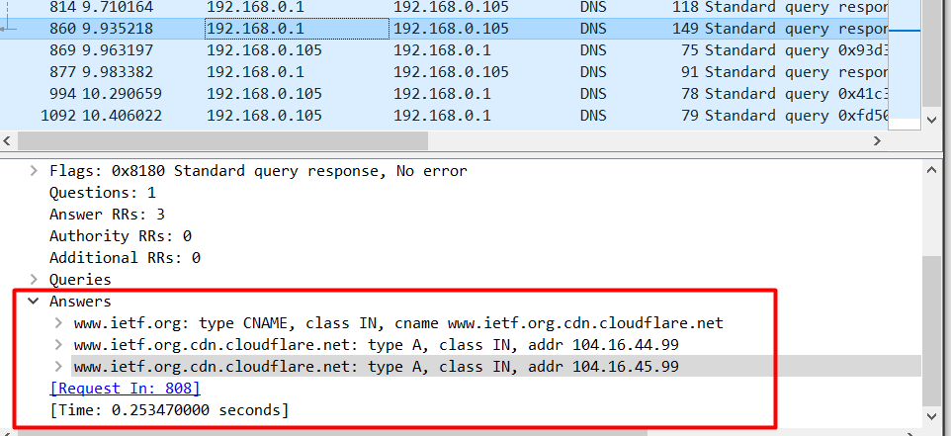

* 1. This web page contains images. Before retrieving each image, does your host issue new DNS queries?

Yes, my host did issue new DNS queries before the images were retrieved.

**Part2: Issuing DNS using nslookup**

Answer the following questions:

* 1. What is the destination port for the DNS query message? What is the source port of DNS response message?



* 1. To what IP address is the DNS query message sent? Is this the IP address of your default local DNS server?

Yes.

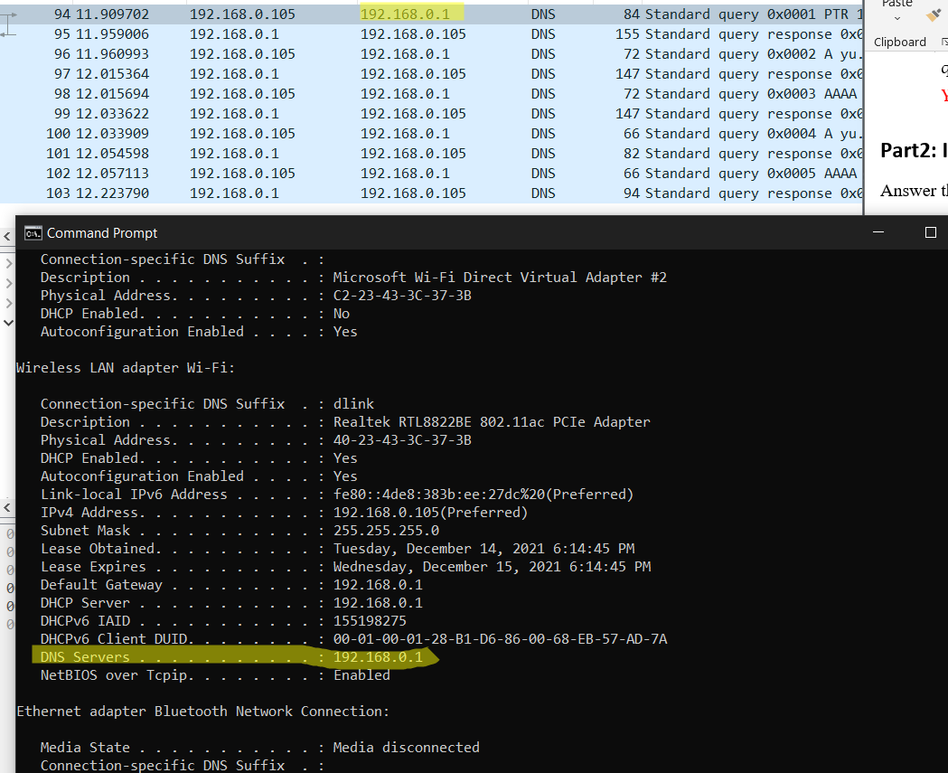

* 1. Examine the DNS query message. What “Type” of DNS query is it? Does the query message contain any “answers”?

It has a type of AAAA



* 1. Examine the DNS response message. How many “answers” are provided? What do each of these answers contain?

Same as the answer before, it doesn’t have any answers

**Homework: Try entering this command nslookup –type=NS yu.edu**

